|  |  |  |  |
| --- | --- | --- | --- |
| **Roll No** | **Name** | **Class** | **Address** |
| 1 | Sunil Umesh Patil | SYCO | Gargoti |
| 2 | Pradnya Sanket Gojare | SYCO | Kolhapur |
| 3 | Sammer Ajay Sutar | SYCO | Kagal |

**Concept Of Database**

**Advantages of Database Management System**

**1. Data Integrity**

Data integrity means data is consistent and accurate in the database. It is essential as there are multiple databases in DBMS. All these databases contain data which is visible to multiple users. Therefore, it is essential to ensure that data is consistent and correct in all databases for all users.

**2. Data Security**

Data security is a vital concept in a database. Only users authorized must be allowed to access the database and their identity must be authenticated using username and password. Unauthorized users shouldn’t be allowed to access the database under any circumstances as it violets the integrity constraints.

A DBMS provides a better platform for data privacy thus helping companies to offer an improved data security.

**3. Better data integration**

Due to the database management system, we have access to well managed and synchronized form of data making it easy to handle. It also gives an integrated view of how a particular organization is working and keeps track of how one segment of the company affects another segment.

**4. Minimized Data Inconsistency**

Data inconsistency occurs between files when various versions of the same data appear in different places. Data consistency is ensured in the database; there is no data redundancy. Besides, any database changes are immediately reflected by all users, and there is no data inconsistency.

**5. Faster Data Access**

The database management system helps the users to produce quick answers to queries making data accessing accurate and faster.

# Application of DBMS

1. **Railway Reservation System –**  
   In the rail route reservation framework, the information base is needed to store the record or information of ticket appointments, status about train’s appearance, and flight. Additionally, if trains get late, individuals become acquainted with it through the information base update.
2. **Library Management System –**  
   There are loads of books in the library so; it is difficult to store the record of the relative multitude of books in a register or duplicate. Along these lines, the data set administration framework (DBMS) is utilized to keep up all the data identified with the name of the book, issue date, accessibility of the book, and its writer.
3. **Banking –**  
   Database the executive’s framework is utilized to store the exchange data of the client in the information base.
4. **Education Sector –**  
   Presently, assessments are led online by numerous schools and colleges. They deal with all assessment information through the data set administration framework (DBMS). In spite of that understudy’s enlistments subtleties, grades, courses, expense, participation, results, and so forth all the data is put away in the information base.
5. **Credit card exchanges –**  
   The database Management framework is utilized for buying on charge cards and age of month to month proclamations.
6. **Social Media Sites –**  
   We all utilization of online media sites to associate with companions and to impart our perspectives to the world. Every day, many people group pursue these online media accounts like Pinterest, Facebook, Twitter, and Google in addition to. By the utilization of the data set administration framework, all the data of clients are put away in the information base and, we become ready to interface with others.
7. **Broadcast communications –**  
   Without DBMS any media transmission organization can’t think. The Database the executive’s framework is fundamental for these organizations to store the call subtleties and month to month postpaid bills in the information base.
8. **Account –**  
   The information base administration framework is utilized for putting away data about deals, holding and acquisition of monetary instruments, for example, stocks and bonds in a data set.
9. **Online Shopping –**   
   These days, web-based shopping has become a major pattern. Nobody needs to visit the shop and burn through their time. Everybody needs to shop through web based shopping sites, (for example, Amazon, Flipkart, Snapdeal) from home. So all the items are sold and added uniquely with the assistance of the information base administration framework (DBMS). Receipt charges, installments, buy data these are finished with the assistance of DBMS.
10. **Human Resource Management –**   
    Big firms or organizations have numerous specialists or representatives working under them. They store data about worker’s compensation, assessment, and work with the assistance of an information base administration framework (DBMS).
11. **Manufacturing –**   
    Manufacturing organizations make various kinds of items and deal them consistently. To keep the data about their items like bills, acquisition of the item, amount, inventory network the executives, information base administration framework (DBMS) is utilized.
12. **Airline Reservation System –**   
    This framework is equivalent to the railroad reservation framework. This framework additionally utilizes an information base administration framework to store the records of flight takeoff, appearance, and defer status.

## DBMS Three Level Architecture Diagram

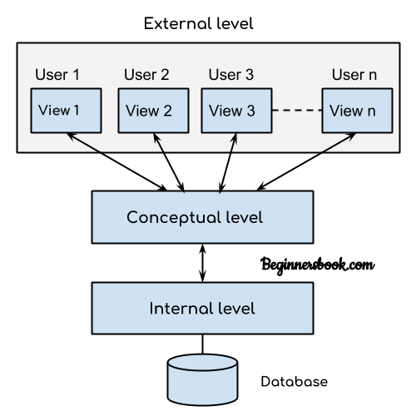

This architecture has three levels:  
1. External level  
2. Conceptual level  
3. Internal level

## 1. External level

It is also called **view level**. The reason this level is called “view” is because several users can view their desired data from this level which is internally fetched from database with the help of conceptual and internal level mapping.

The user doesn’t need to know the database schema details such as data structure, table definition etc. user is only concerned about data which is what returned back to the view level after it has been fetched from database (present at the internal level).

External level is the “**top level**” of the Three Level DBMS Architecture.

## 2. Conceptual level

It is also called **logical level**. The whole design of the database such as relationship among data, schema of data etc. are described in this level.

Database constraints and security are also implemented in this level of architecture. This level is maintained by DBA (database administrator).

## 3. Internal level

This level is also known as physical level. This level describes how the data is actually stored in the storage devices. This level is also responsible for allocating space to the data. This is the lowest level of the architecture.

# Data Abstraction in DBMS

Database systems are made-up of complex data structures. To ease the user interaction with database, the developers hide internal irrelevant details from users. This process of hiding irrelevant details from user is called data abstraction.

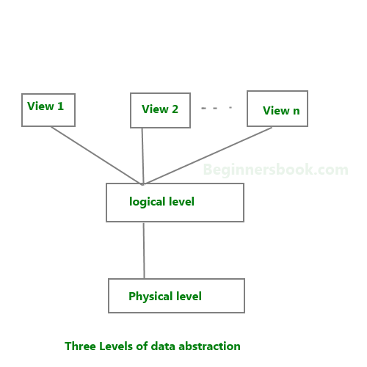

**We have three levels of abstraction**:  
**Physical level**: This is the lowest level of data abstraction. It describes how data is actually stored in database. You can get the complex data structure details at this level.

**Logical level**: This is the middle level of 3-level data abstraction architecture. It describes what data is stored in database.

**View level**: Highest level of data abstraction. This level describes the user interaction with database system.

## Data Independence

A database system normally contains a lot of data in addition to users’ data. For example, it stores data about data, known as metadata, to locate and retrieve data easily. It is rather difficult to modify or update a set of metadata once it is stored in the database. But as a DBMS expands, it needs to change over time to satisfy the requirements of the users. If the entire data is dependent, it would become a tedious and highly complex job.

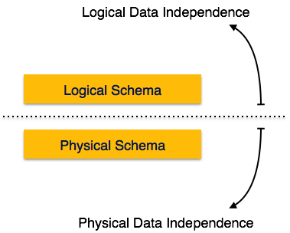

Metadata itself follows a layered architecture, so that when we change data at one layer, it does not affect the data at another level. This data is independent but mapped to each other.

## Logical Data Independence

Logical data is data about database, that is, it stores information about how data is managed inside. For example, a table (relation) stored in the database and all its constraints, applied on that relation.

Logical data independence is a kind of mechanism, which liberalizes itself from actual data stored on the disk. If we do some changes on table format, it should not change the data residing on the disk.

## Physical Data Independence

All the schemas are logical, and the actual data is stored in bit format on the disk. Physical data independence is the power to change the physical data without impacting the schema or logical data.

For example, in case we want to change or upgrade the storage system itself − suppose we want to replace hard-disks with SSD − it should not have any impact on the logical data or schemas.

# Structure of Database Management System

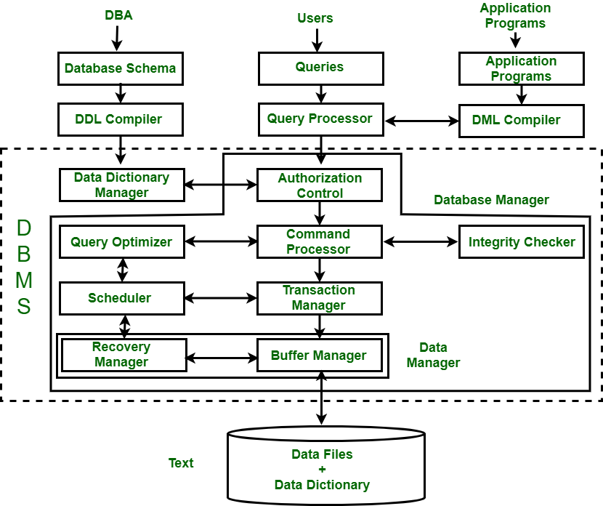

**1. Query Processor :**   
It interprets the requests (queries) received from end user via an application program into instructions. It also executes the user request which is received from the DML compiler.   
Query Processor contains the following components – 

* **DML Compiler –**   
  It processes the DML statements into low level instruction (machine language), so that they can be executed.
* **DDL Interpreter –**   
  It processes the DDL statements into a set of table containing meta data (data about data).
* **Embedded DML Pre-compiler –**   
  It processes DML statements embedded in an application program into procedural calls.
* **Query Optimizer –**   
  It executes the instruction generated by DML Compiler.

**2. Storage Manager :**   
Storage Manager is a program that provides an interface between the data stored in the database and the queries received. It is also known as Database Control System. It maintains the consistency and integrity of the database by applying the constraints and executes the [DCL](https://www.geeksforgeeks.org/sql-ddl-dql-dml-dcl-tcl-commands/) statements. It is responsible for updating, storing, deleting, and retrieving data in the database.   
It contains the following components – 

* **Authorization Manager –**   
  It ensures role-based access control, i.e,. checks whether the particular person is privileged to perform the requested operation or not.
* **Integrity Manager –**   
  It checks the integrity constraints when the database is modified.
* **Transaction Manager –**   
  It controls concurrent access by performing the operations in a scheduled way that it receives the transaction. Thus, it ensures that the database remains in the consistent state before and after the execution of a transaction.
* **File Manager –**   
  It manages the file space and the data structure used to represent information in the database.
* **Buffer Manager –**   
  It is responsible for cache memory and the transfer of data between the secondary storage and main memory.

**3. Disk Storage :**   
It contains the following components – 

* **Data Files –**   
  It stores the data.
* **Data Dictionary –**   
  It contains the information about the structure of any database object. It is the repository of information that governs the metadata.
* **Indices –**   
  It provides faster retrieval of data item.